Northeastern University
CS 5100 Foundations of Artificial Intelligence
Homework and PA 3

NAME: PARSHVA TIMBADIA
EMAIL: timbadia.p@northeastern.edu
NUID: 001091783

Q1>
A)

A | B | C | D | B V C
F | F | F | F | F
F | F | F | T | F
F | F | T | F | T
F | F | T | T | T
F | T | F | F | T
F | T | F | T | T
F | T | T | F | T
F | T | T | T | T
T | F | F | F | F
T | F | F | T | F
T | F | T | F | T
T | F | T | T | T
T | T | F | F | T
T | T | F | T | T
T | T | T | F | T
T | T | T | T | T

Therefore, there are 12 models for which proposition is TRUE.

B)

A | B | C | D | ¬A∨¬B∨¬C∨¬D.
F | F | F | F | T
F | F | F | T | T
F | F | T | F | T
F | F | T | T | T
F | T | F | F | T
F | T | F | T | T
F | T | T | F | T
F | T | T | T | T
T | F | F | F | T
T | F | F | T | T
T | F | T | F | T
T | F | T | T | T
T | T | F | F | T
T | T | F | T | T
T | T | T | F | T
T | T | T | T | F

Therefore, there are 15 models for which proposition is TRUE.

C)

A | B | C | D | (A ⇒ B) ∧ A ∧ ¬B ∧ C ∧ D.
F | F | F | F | F
F | F | F | T | F
F | F | T | F | F
F | F | T | T | F
F | T | F | F | F
F | T | F | T | F
F | T | T | F | F
F | T | T | T | F
T | F | F | F | F
T | F | F | T | F
T | F | T | F | F
T | F | T | T | F
T | T | F | F | F
T | T | F | T | F
T | T | T | F | F
T | T | T | T | F

Therefore, there are 0 models for which proposition is TRUE.

Q2>

The scenario I am considering to answer the given question is mentioned below.

So the robot will always keep on checking for the pedestrians waiting next to crosswalk on either side of the road. At that moment the robot will wait for a short time so as to be able to guide more people while crossing, and in the meanwhile turn the crossing lights countdown on. The robot will keep on detecting the crossing light to turn on, and as soon as it happens the robot will now scan whether there is any other object on the crosswalk apart from a Human-like car or bike. If the crosswalk is clear it will go to the middle of the crosswalk, showing signal to the vehicles to halt and direct the pedestrians to cross.

Also, one thing that we will add here a special indicator for certain car lanes to continue wherever the agent senses that people have already crossed that lane. This will help us to not make the traffic completely to a standstill. Once all of the people have crossed the road the robot will go to its initial state.

A>
So as per the above mentioned scenario the agent need to be aware of the following
- Pedestrians
- Crossing Indicator
- Cross Walk
- Vehicle Detection
- Lane Detection

- Taxonomy: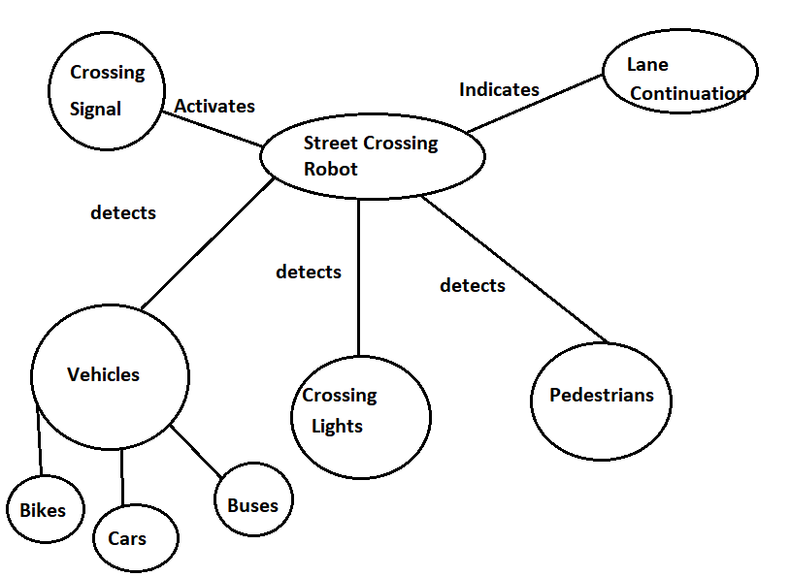

- Events:

Monitoring_Pedestrians: The agent needs to keep track of the pedestrians on either side of the road because the crossing signal timer will be activated only when the agent senses the human.

Monitoring_Crossing_Lights: Once the crossing signal timer is activated the agent needs to monitor for the crossing lights to turn on.

Monitoring_Objects: As soon as the crossing light is turned on, the agent senses for any objects like vehicle within the boundaries of the crosswalk.

Move_to_Middle_and_signal: The agent next moves to the middle of the street and indicates all the vehicles to halt, while simultaneously assisting pedestrians.

Lane_Cross_Check_and_Indicator: So basically the road is split into multiple lanes. When the robot detects that the pedestrians have crossed the lanes and there is not one that will cross that lane now, the robot will indicate the vehicles at that lane to continue so as to not to keep the traffic at a complete halt.

Pedestrian_Cross_Check: The robot will continue to check if all of the pedestrians have crossed the road or not.

Q3>

- p → A is true.
q→ B is true

Logic : p ^q

- p→ A is True.
q→ B is True.

Logic: p ⇒q

- p→ Student studies for the test
q→ Student will do well on the test.

Logic: p⇒q ^q ⇒p
Hence, p⇔q

IV. P→ Student is dry
Q→ Raining outside
R→ Student has an umbrella
S→ Student has a hoodie
T→ Raining heavily.

Logic: P ^Q ⇒(R ∨S) ^ ~T

V. L → Students hand in HW late
C→Students hand in HW complete
P →Students will lose points.

Logic: ~((~L ∨ C ) → ~P)

Q4>

Propositional Logic(Question): A ∨(A ∧ B) ⇐⇒ ¬(A ∧ B ∧ C)

Simplification: According to Absorption Law that is p ∨(p ∧ q) ⇐⇒ p.
We can convert the above question into.

A ⇐⇒ ¬(A ∧ B ∧ C)

English Sentence(Answer):

A is TRUE iff negation of A and B and C [ ie. ~(A ^B^C)] is TURE, which is possible if either B or C/ both of them are FALSE.

Explanation/ Reasoning : So basically we are trying to prove both the side as equivalent. That is they both(LHS and RHS) should be either True or False.

- For TURE case(Case 1):

LHS can only be True only when A is True.
RHS can be True only when at least either of them(B,C) is False.

- For FALSE case(Case 2):

LHS can only be False only when A is False.
However, RHS is only possible if (A and B and C) are True. So as we have considered A to be False, it eliminates all the possibilities of RHS to be False.

Hence, we will just consider Case 1.

Q5>

A>

∃x(Eng(x) ^ ~ Maths(x))
Eng(x)= Students pass in English
Maths(x)= Students pass in Maths

B>

∀x (R(x) ^E(x))

R(x)= Students registered in a class
E(x)= Students Enrolled in a University

C>

∃x∃y Uncle(x) V Aunt(x)⇒ Nephew(y,x) V Niece(y,x) ^ ~(x=y)

Nephew(y,x)/ Niece(y,x) = Nephew(y)/Niece(y) has Aunt(x)/Uncle(x)

- ∀x (Old(x) ^ Strong(x)) ⇒ ~Wither(x)

6>
- All the possible instance from the given schema is mentioned below, considering the preconditions are satisfied.

Fly(P1, JFK, JFK)
Fly(P1, JFK , SFO)
Fly(P2, SFO, SFO)
Fly(P2, SFO, JFK)

B>

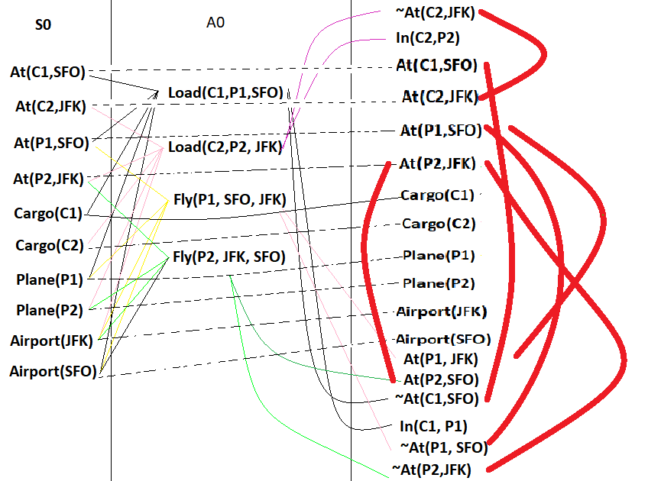

Layer 0 Layer 1 Layer2(S2)

Here, the Dark and thick Red one are the Mutexes. Dotted lines are the persistence or maintenance lines. Others are the effects of the action.

Q7>

C>

1.We the symbols on the map totally depends on how detailed it is.

For the detailed map the type of symbols are possible are road symbols like directions, famous locations like restaurants and malls around, location of various banks and railway stations, while for the not so detailed maps it could include the river routes, railway routes, capital of the state or country, roads symbols too but this time only of roads like national highways, city symbol.

- Explicit Sentence Example:

- A particular mounted located xyz above the altitude point.(Assuming 2D Map)
- This monument is located at (x,y) co-ordinates.(Assuming the Map doesn’t provide co-ordinates)
- A river XYZ runs in this direction.

Implicit Sentence Example:

- State A is larger than State B in term of land. (As we have a 2D map we can check for it without some explicit details)
- State A is located in Northern most Part of Country B.
- A XYZ river runs through this State A , State B and State C.

3.

The physical structure of the country that cannot be represented according to me are as follows:

1. The map cannot tell us about the changes that have been made in recent years.

Example: Monument XYZ was created in 1939.

2. The map cannot be ambiguous.

Example: The capital of the country is located in the North or South.

3. The map cannot tell about the changes that are dynamic.

Example: Many heavy traffic roads in India get extended into the opposite lanes to overcome the overwhelming traffic. Such types of sudden changes are not reflected.

B>

(∃x x = x) ⇒ (∀ y ∃z y = z).

The first part of the sentence is True as every object is going to equal to itself. Now the entire validity depends on the second part of the equation. Now for the second part, there exists every y which is equal to some y and hence is valid. Since both of the parts turn out to be True. It is a VALID sentence.

∀ x P(x) ∨ ¬P(x).

In this sentence, there exist every value of x in relation denoted by P(x) which can be True or False. However, the second part is OR-ed with the negation of P(X) and hence it will always be a VALID sentence.

∀ x Smart(x) ∨ (x = x).

In this sentence, there exists every x which is going to be equal to itself an hence the second part of the sentence is always going to be True and as there as OR operator the sentence is considered as VALID irrespective of Smart(x).

C>

1.(1)correctly expresses the English sentence

2. (3) is syntactically valid but does not express the meaning of the English sentence.

- (2) syntactically invalid and therefore meaningless

- (2) syntactically invalid and therefore meaningless.

D>
Occupation(Joe, Actor) ∧ ∃x ~(x=Actor) ∧ Occupation(Joe, x)

